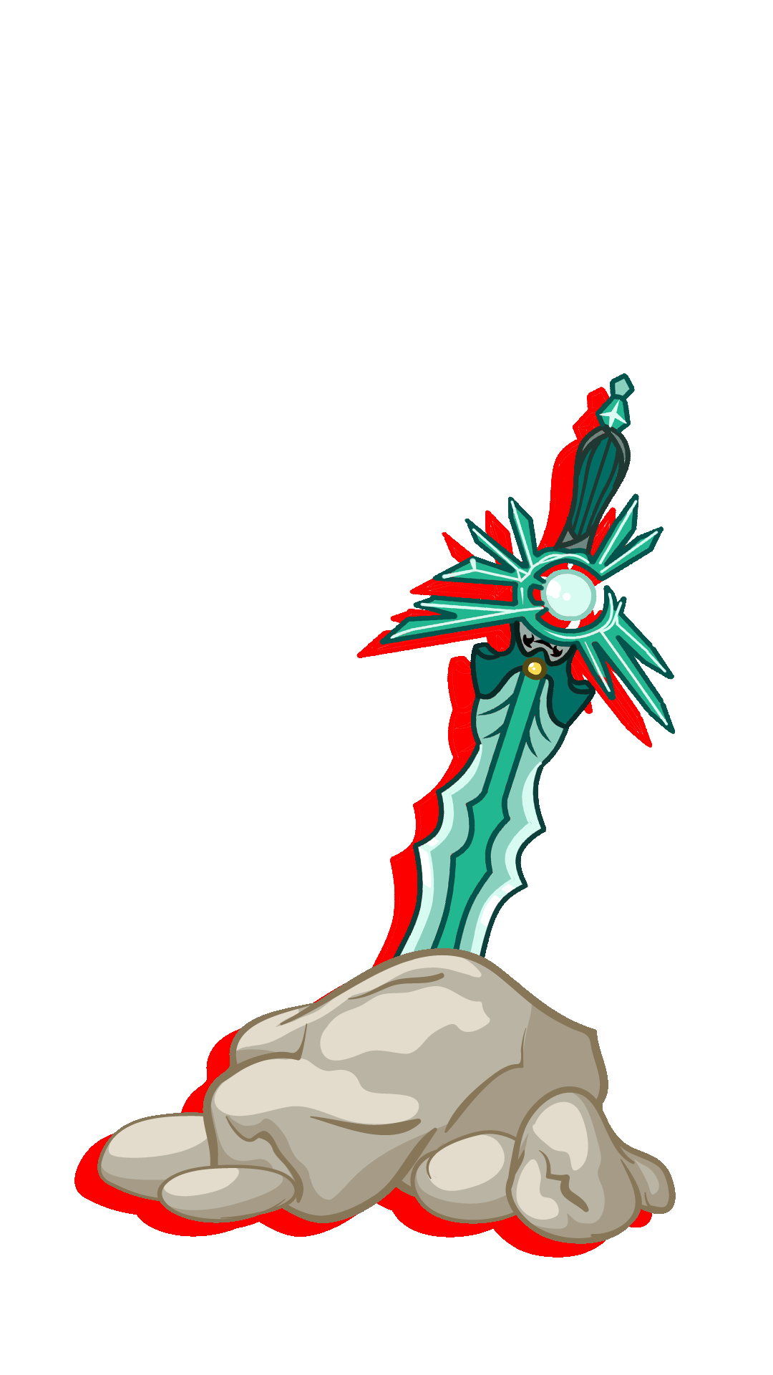

**MANUAL**



**INSTALLATION --------------------------------------- 1  
GETTING STARTED --------------------------------------- 2**

**MAIN GAME ---------------------------------------- 3**

**MINIGAMES ---------------------------------------- 9**

**OPTIONS ---------------------------------------- 15**

**TABLE OF CONTENTS**



**Installation**



**SETTING UP YOUR DEVICE**

1. Go to Settings.
2. Scroll Down to Security.

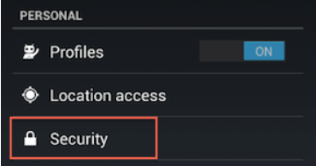

1. Select Unknown Sources (Selecting this option will allow you to install apps outside of the Google Play store).

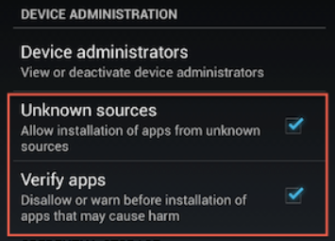

Note: Depending on your device, you can also choose to be warned

before installing harmful apps. This can be enabled by selecting the

Verify apps option in the Security settings.

**INSTALLING THE APP**

1. Open the “Pedro’s Journey” apk file.
2. Click “Install”.





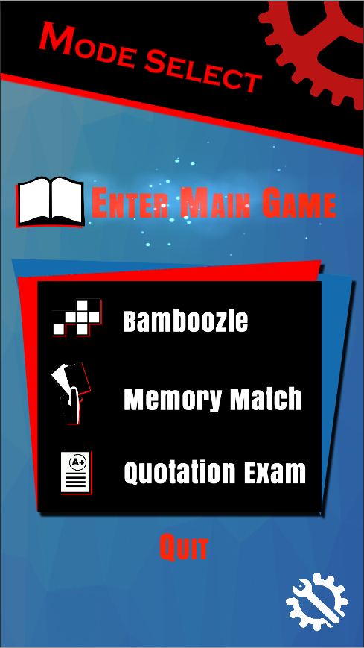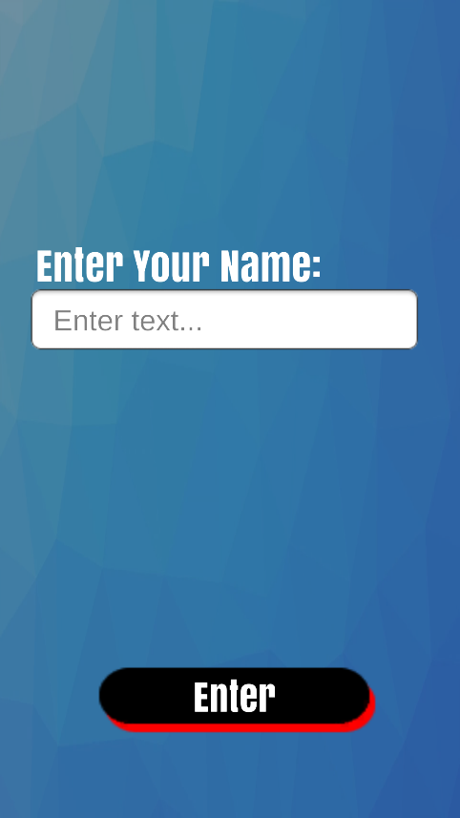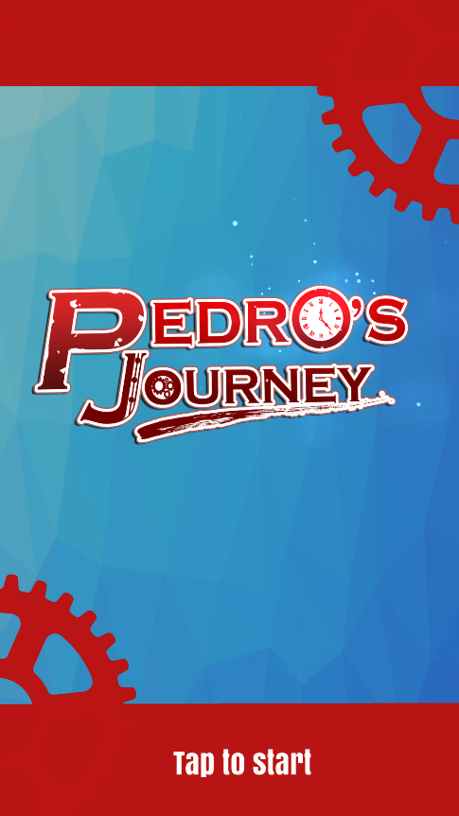

Now, choose a “Game Mode” and now you’re good to go.

Then you will need to enter a name in order to proceed to the “Mode Select Menu”, after you enter your name just press “Enter” to proceed.

First, the you will be greeted with the “Title Screen”, just “tap” to start

**Getting Started**



**Main Game**

**STORY**

The story of Pedro’s Journey starts off with your self-named main character and his 2 friends near the end of the National Youth Day events with all the participants gathered around in one place as the NYD organizer is wrapping up the event with a speech.

     Before the event was even able to wrap up, portals appeared around the venue and shadow-like monsters appeared from the portals and started killing the participants. As the MC and his friends tried to escape the situation, they were eventually cornered by the shadows and his 2 friends had their souls taken away by the shadows.

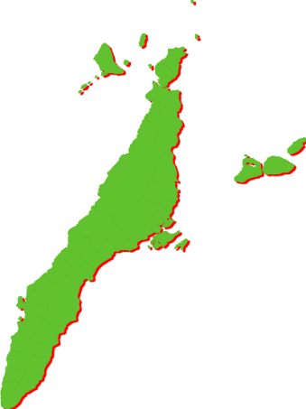

**CASTS**

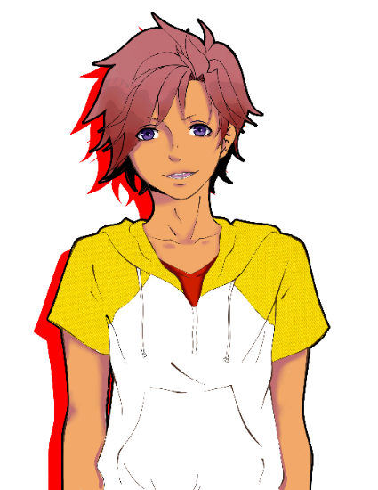

**Main Character**

He is your self-named main character of the story. He doesn't have a set name since the players will be naming him themselves.

**Pedro**

The secondary main character of the story. A spirit that gives the MC his supernatural powers, and assists the main character throughout his journey.





**Friend 1**

One of the main character’s friends

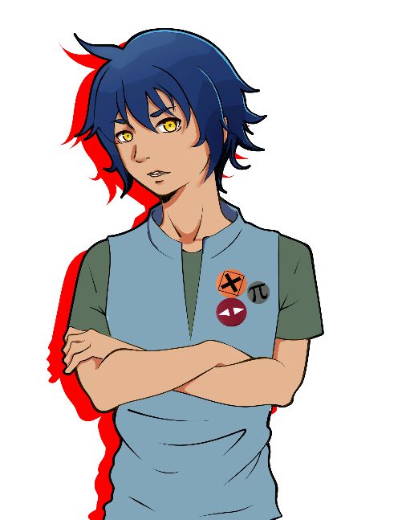

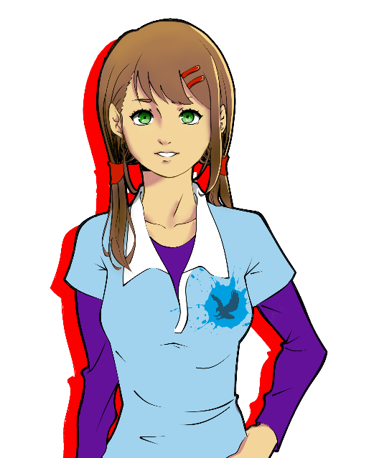

**Friend 2**

One of the main character’s friends

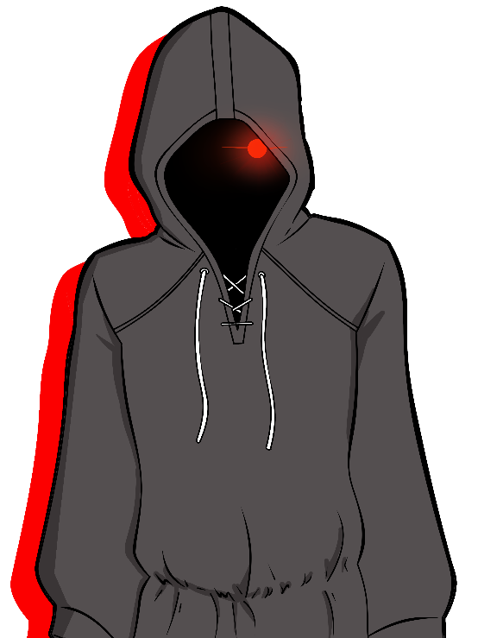

**Mysterious Figure**

A Mysterious Hooded Figure who appears and murders the Organizer in a split second, what could be his objective?



**Main Game Controls**

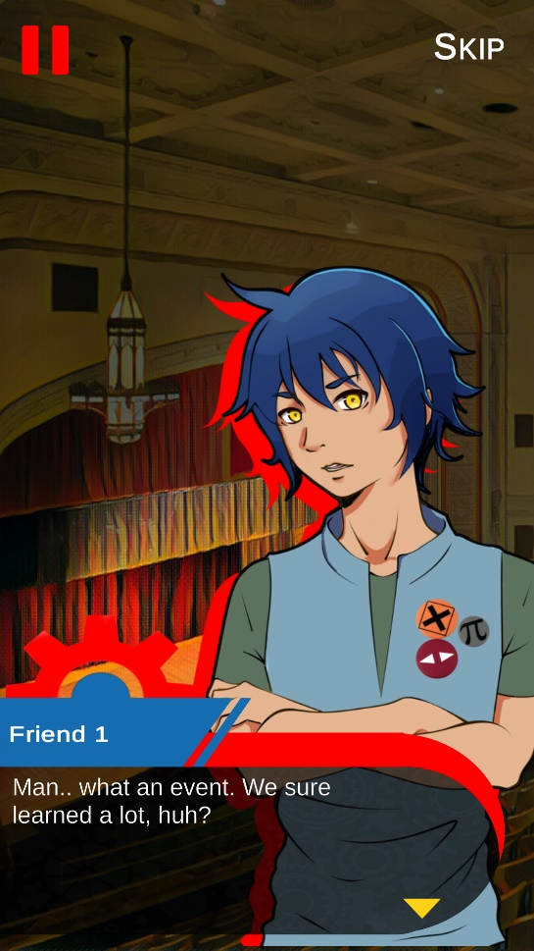

**PAUSE BUTTON**

**SKIP BUTTON**

**DIALOGUE BOX**

|  |  |
| --- | --- |
| PAUSE BUTTON | It enables the player to pause the game |
| SKIP BUTTON | It enables the player to skip the dialogue and engage battle right away |
| DIALOGUE BOX | It enables the user to proceed the with the dialogue |

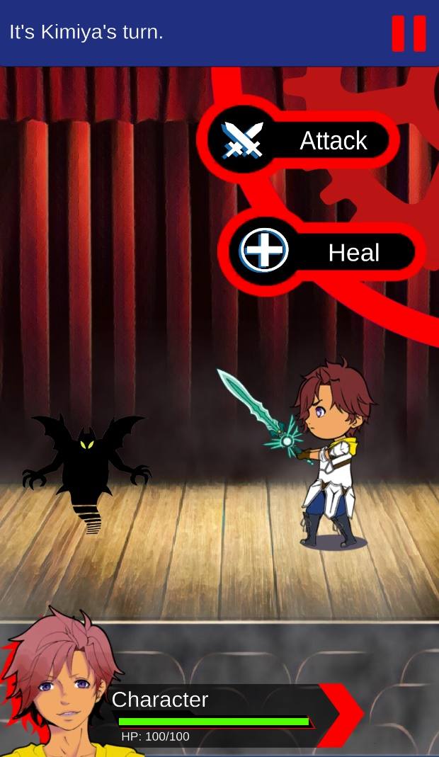

|  |  |
| --- | --- |
| PAUSE BUTTON | It enables the player to pause the game |
| ATTACK BUTTON | It enables the player to damage the enemy |
| HEAL BUTTON | It enables the player to heal the his/her character |
| HEALTH/HP BAR | It enables the player to see the remaining health of his/her character |

**HEALTH/HP BAR**

**PAUSE BUTTON**

**HEAL BUTTON**

**ATTACK BUTTON**

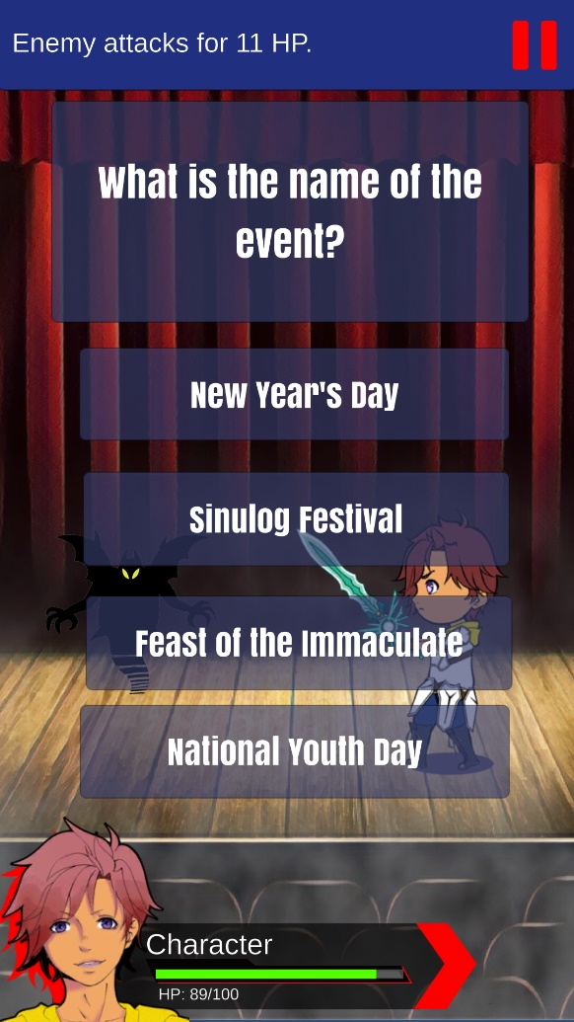

|  |  |
| --- | --- |
| QUESTIONAIRE BOX Module | It enables the player to see the given question |
| CHOICE BUTTON | It enables the player to tap and select the answer of his/her choice |

**CHOICE BUTTONS**

**QUESTIONAIRE BOX**

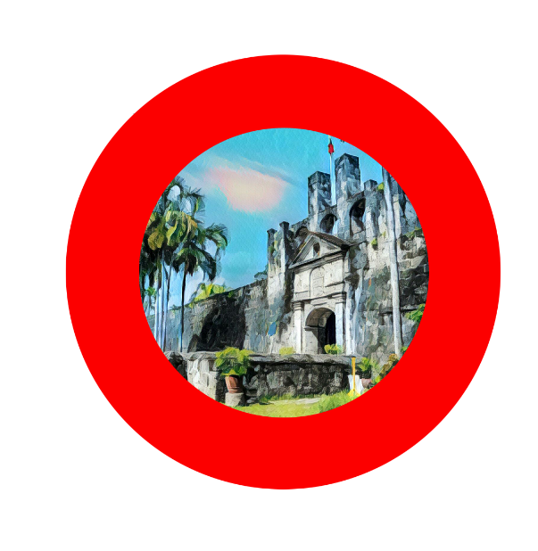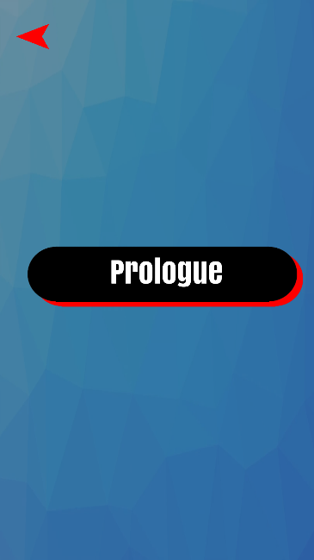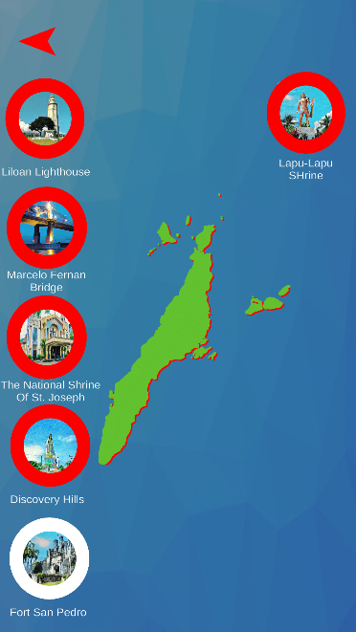

**MAIN GAME**

**Menu**

**PROLOGUE**

Before gaining access to all the rest of the chapter you need to clear the prologue first to gain entry to the rest of the chapters. Press the Prologue button to play the “Prologue Chapter” of the main game.

**MAP**

After playing with the Prologue Chapter you will be greeted with an extensive map of Cebu and shows different locations where the main story will take place.

**LOCATION OR CHAPTER BUTTONS**

These buttons show the different locations of the island Cebu. Each of them contains different chapters of the story that took place on that location, but before you can gain access to its contents, you will need a specific QR Code of that location in order to unlock the contents of that chapter.

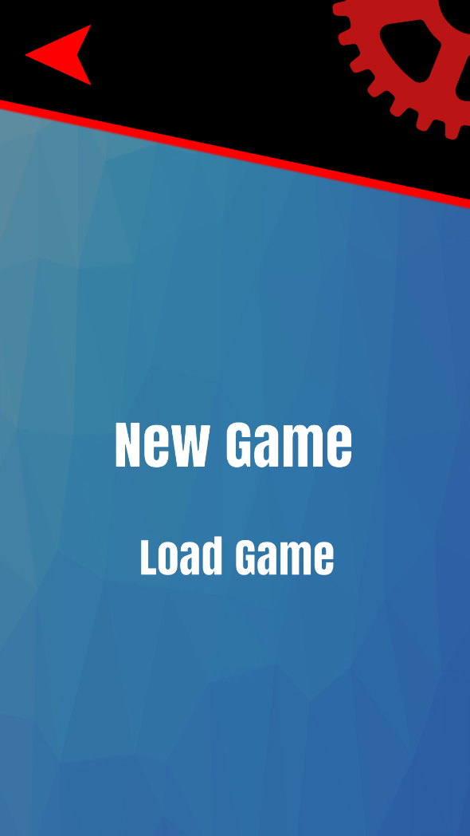

**NEW GAME**

This option allows player to start from the very beginning of the main story of the game

Note: Starting a new game will delete your progress if you already started the game

**LOAD GAME**

This option allows player to start from the very beginning of the main story

**MAIN GAME**

**Load/New Game**



**MAIN GAME**

**Battle**

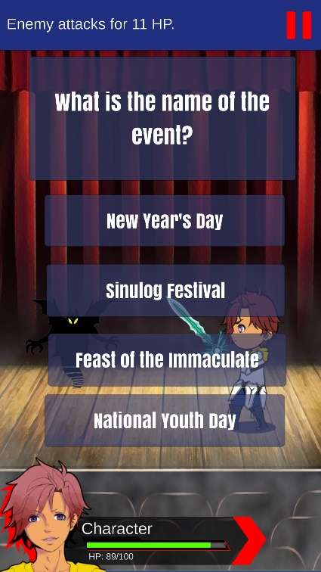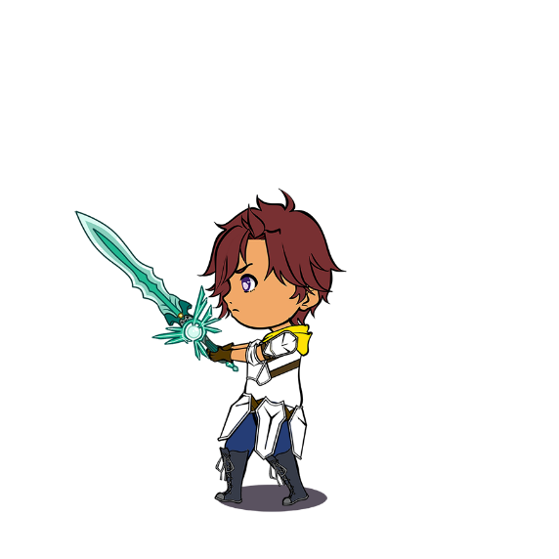

**BATTLE SYSTEM**

This game’s battle system is turn-based and each side has their respective turns. The main mechanic of each battle is having the player answer the questions per turn and if the player doesn’t answer the question correctly, he/she will lose a turn. Outwit your enemies by your knowledge of the historical and religious facts of Cebu.

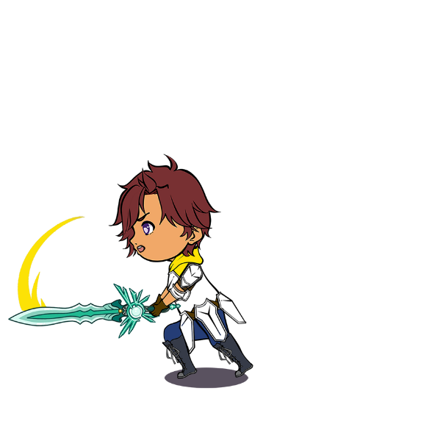

**ABILITIES**

**Attack**

Pressing this will allow the player to damage the enemy

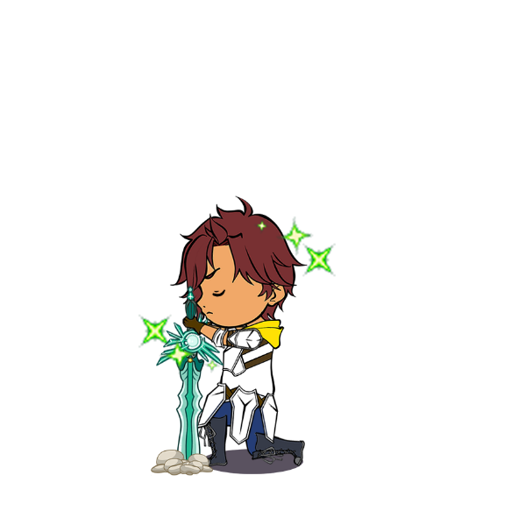

**Heal**

Pressing this will allow the player to heal and regain some health points



**QUOTATION EXAM**

a game where you guess the famous religious figure who said the quote. It will be multiple choice.

**MEMORY MATCH**

a card game where the player matches 2 cardsthat have a relationship with each other out of several faced down cards.

Besides the main game, this app includes three mini games for the players to have fun with.

**MINIGAMES**

**BAMBOOZLE**

a crossword game where you form a set of letters to form words related to Cebu's history. Will have an easy, medium, and hard difficulty.

|  |  |
| --- | --- |
| BACK button | It enables the player to traverse back to the previous screen. |
| TIMER | It enables the player to see the time left |
| CARDS | It enables the player to tap the back of the card to flip it. |

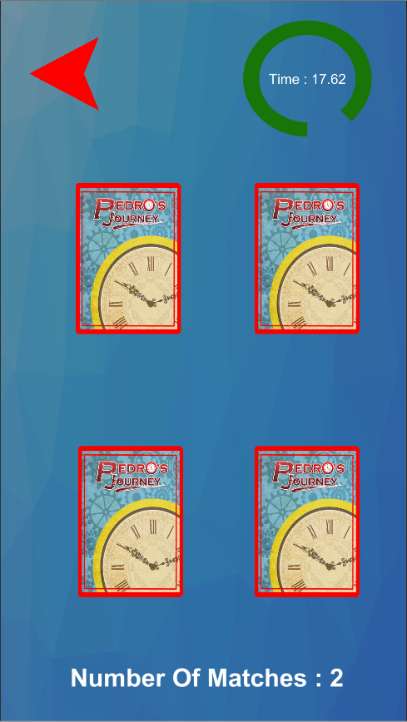****

**OBJECTIVE**

The player will try to match two cards that have a relationship with each other out of several faced down cards. if the player is able to finish before the time runs out the then, player wins, or else the player will lose.

**MINIGAMES**

**Memory Match**

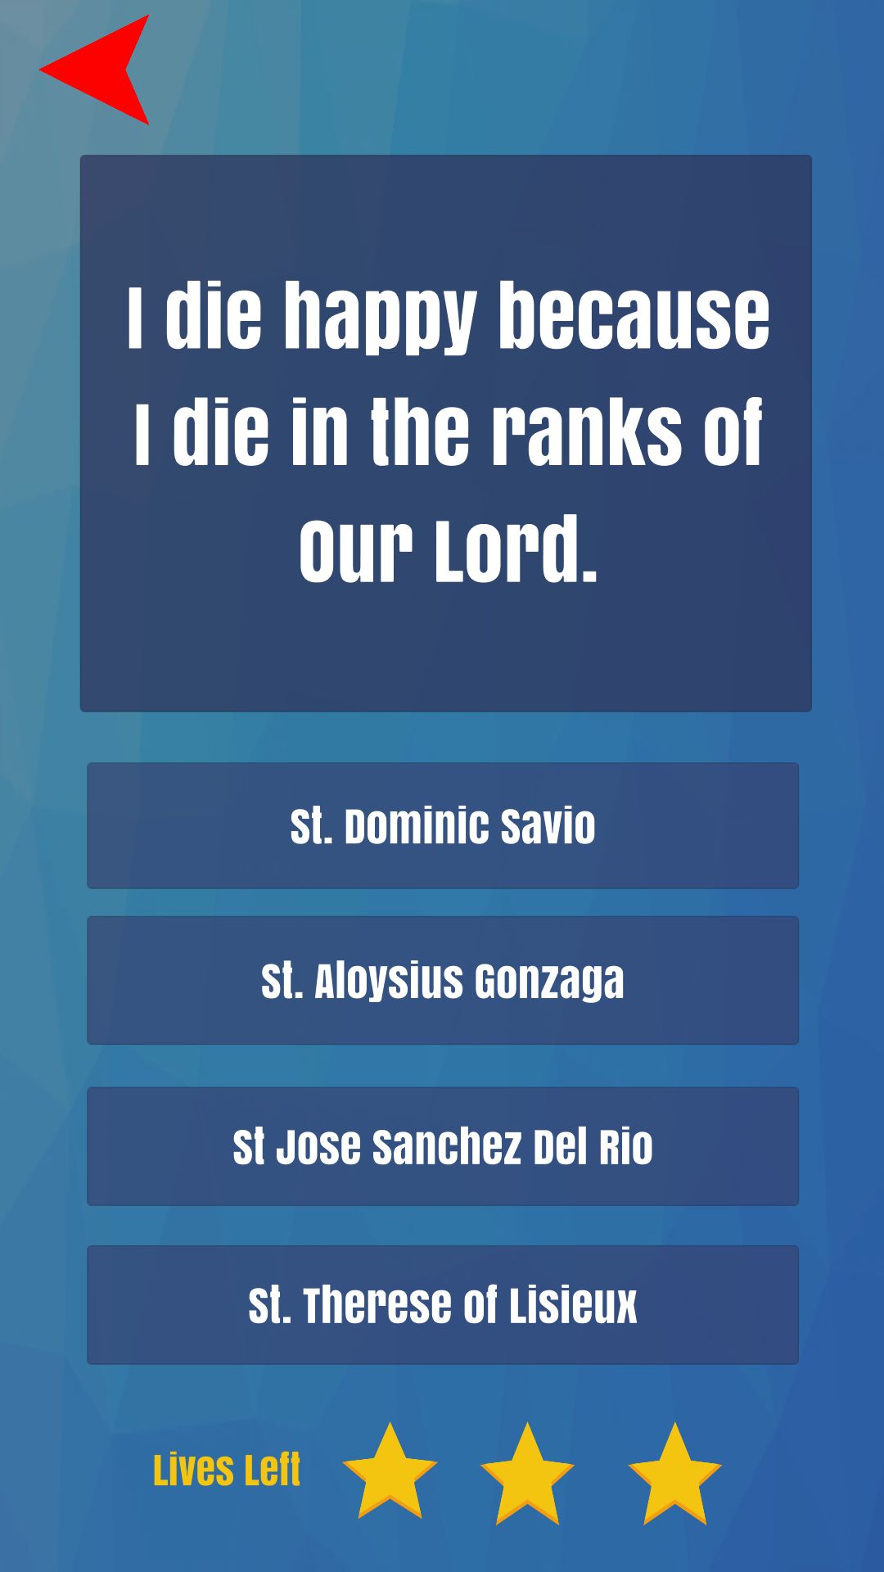

|  |  |
| --- | --- |
| BACK button | It enables the player to traverse back to the previous screen. |
| QUESTIONAIRE BOX | It enables the player to see the given question |
| CHOICE button | It enables the player to tap and select the answer of his/her choice |
| LIVES | It enables the player to see the remaining lives left |

**OBJECTIVE**

The player will try to guess the famous figure who said the quote, if the player keeps answering incorrectly eventually his lives will run out and the player will lose.

**MINIGAMES**

**Quotation Exam**



**MINIGAMES**

**Bamboozle**

**OBJECTIVE**

The player will try to guess the word with following “letters” given to the player, if the player is able to finish before the time runs out the then, player wins, or else the player will lose.

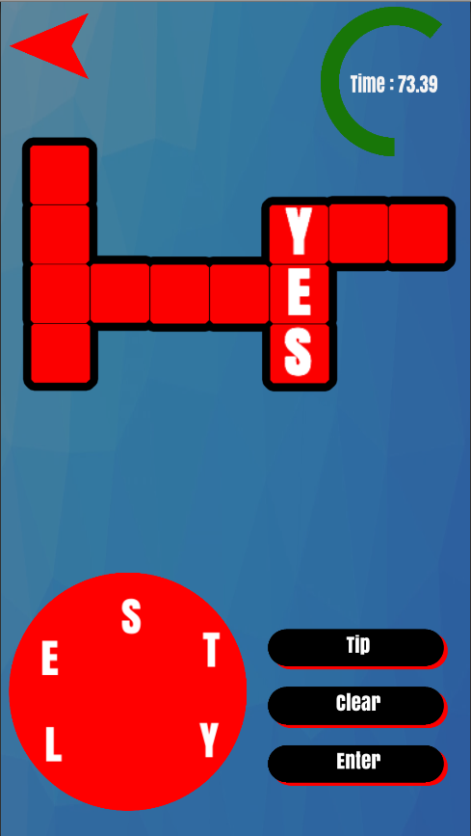

|  |  |
| --- | --- |
| BACK button | It enables the player to traverse back to the previous screen. |
| TIMER | It enables the player to see the time left |
| TIP button | It enables the player to see a picture as a hint of the word. |
| CLEAR button | It enables the player to reset the letters selected |
| ENTER button | It enables the player to enter the word selected and checks if the word is right or not. |
| SELECT LETTER | It enables the player to select the letter of his/her choice to form a word. |

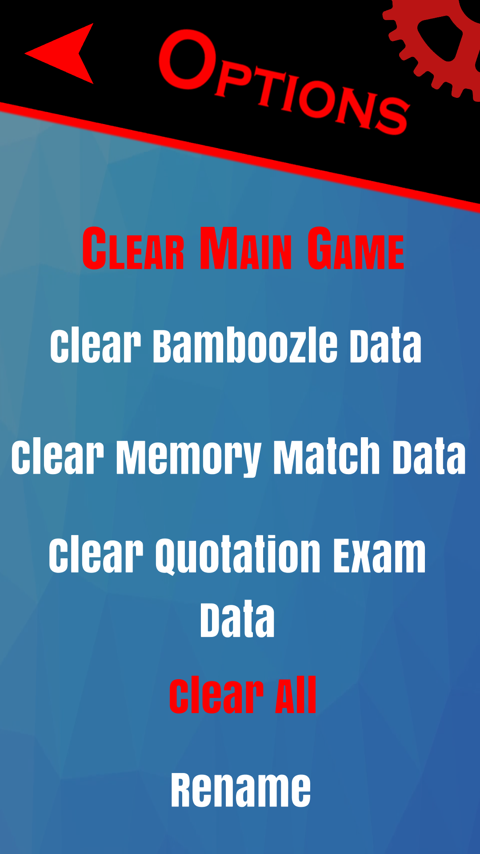

|  |  |
| --- | --- |
| CLEAR MAIN GAME button | It enables player to clear main game’s save data |
| CLEAR BAMBOOZLE DATA button | It enables player to clear Bamboozle’s save data |
| CLEAR MEMORY MATCH DATA button | It enables player to clear Memory Match’s save data |
| CLEAR QUOTATION EXAM DATA button | It enables player to clear Quotation Exam’s save data |
| CLEAR ALL button | It enables player to clear all games data |
| RENAME button | It enables player to rename the Main Character’s name. |

**OPTIONS**